Assignment 6 from Chapter 9

1. Draw the waveform of the following Design

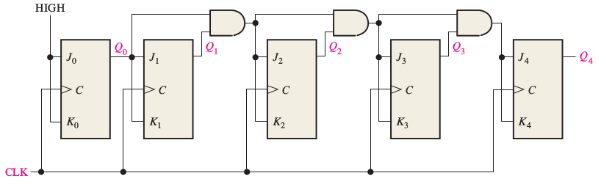

1. Design UP/DOWN synchronized counter for Sequence given below using the following steps:
   1. State Diagram (already given)
   2. Next State Table
   3. Flip-Flop Transition Table
   4. Karnaugh Maps
   5. Logic Expressions for Flip-Flop Inputs
   6. Counter Implementation